Screen shots to assist with ICON language translation

1. Once on the website you may need to right click on the orange circle to ‘open with Microsoft edge’

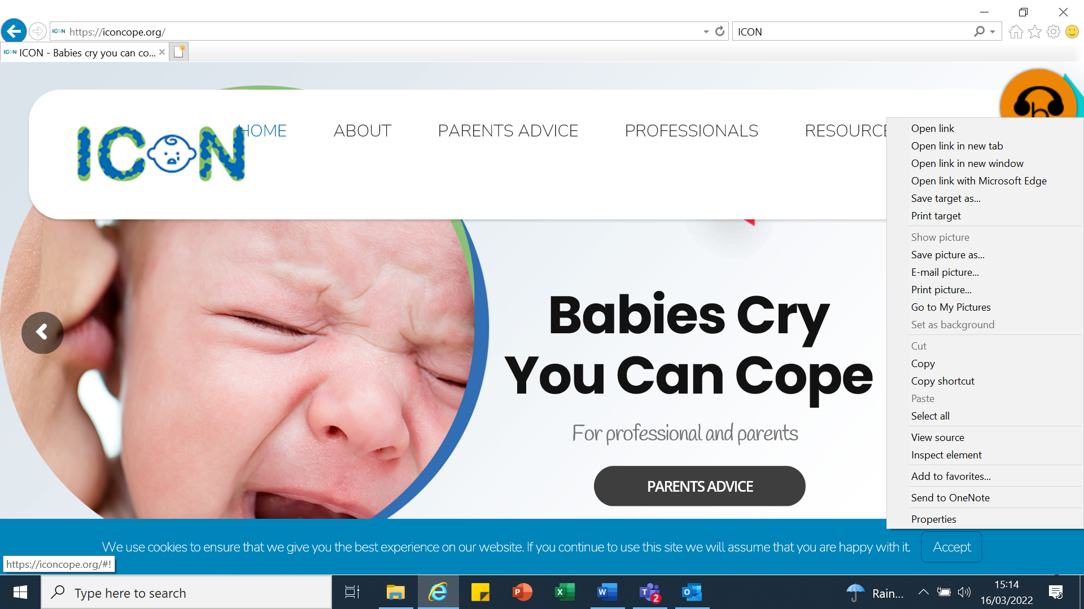

1. Click on professionals’ tab 3. Then click on this symbol

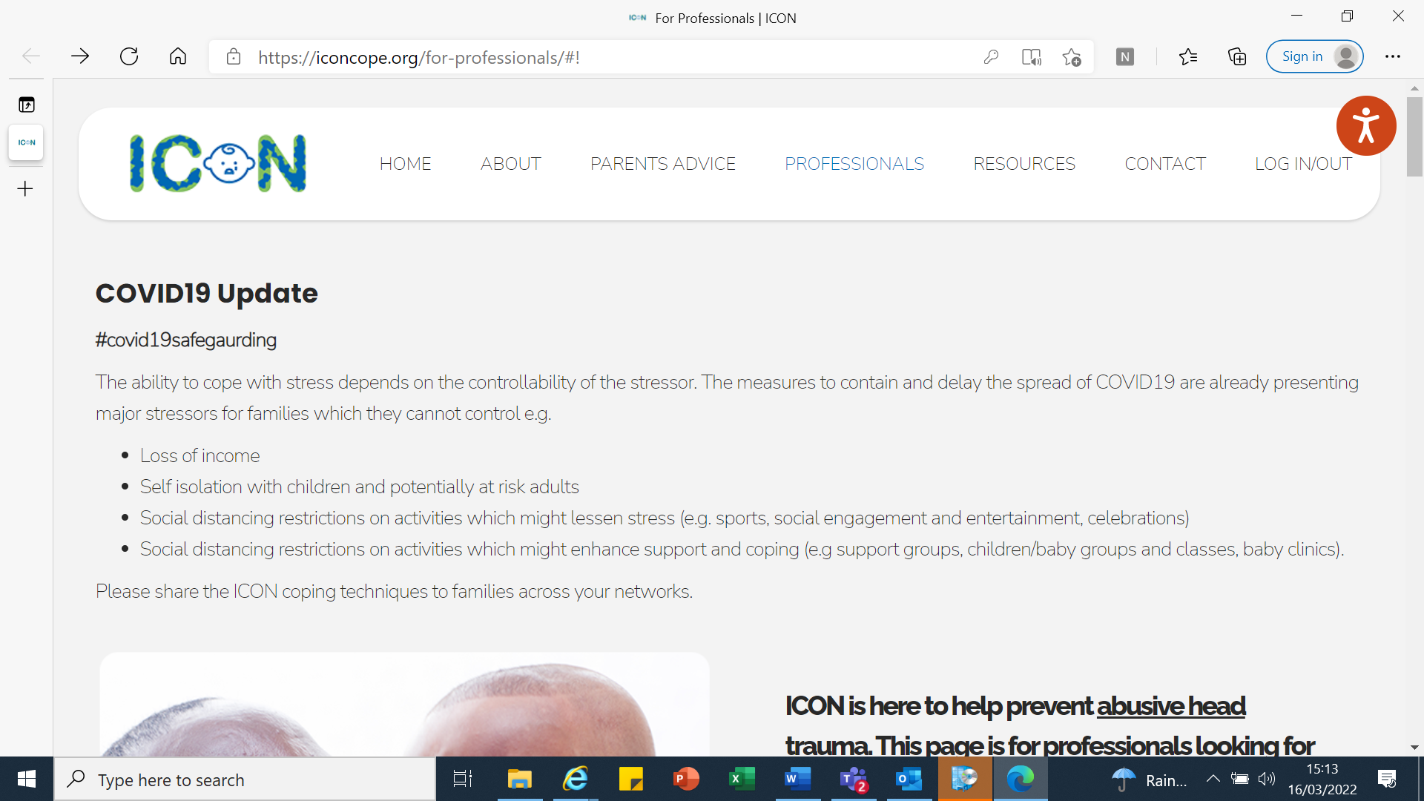

4. Then click on this it will give you the option to choose from a range of translated options. You can then scroll to the leaflets at the bottom of the pages and they will have been translated in the language of your choice. Examples below:

