WSP FaST Reporting Form between Practitioners or Agencies
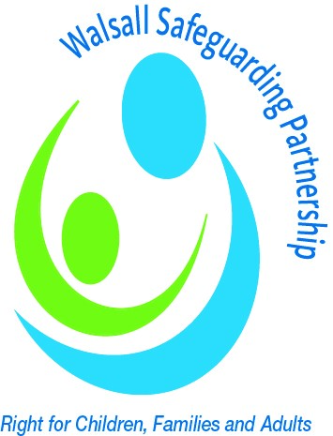

At all stages of FaST, records of discussions and any decisions must be recorded in writing and shared with any relevant personnel.

All matters relating to the protection of children or adults, where there is imminent risk, must be resolved within 24 hours. This will require moving promptly through the stages of the FaST process. However, this form should still be completed.

Finding a Solution Together

Name of child or adult with Care and support needs:

What are you worried about? Summary of reason for Finding a Solution Together – include views of all agencies concerned: what outcome is required.

What action do you believe is needed?
TELL US WHAT YOU HAVE DONE SO FAR…

Stage | Date Contact made | Who did you contact | How did you contact them | Outcome/Reason for moving to next Stage
1.

2.

3.

4.

If you have not found a suitable resolution on completion of Stage 4 (Day 8) then please forward this completed form on to the Walsall Safeguarding Partnership Safeguardingbusinessunit@walsall.gov.uk to escalate to Stage 5.

5.

Additional Notes
Signature of Escalation  Manager |  | Name:
 |  | Job title:
 |  | Agency:
 |  | Date:
Signature of Challenged  Manager |  | Name:
 |  | Job title:
 |  | Agency:
 |  | Date:

